Reading Hamlet – Transcriber's Manual Draft

Marginalia:

Example 1 – Simple marginalia:
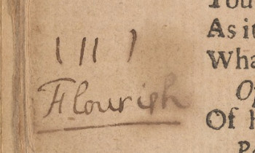
<marginalia>
<language ident="EN">
<position place="left_margin" book_orientation="0">
<marginalia_text>
(11)
Flourish
</marginalia_text>
<person name="Ghost"/>
</position>
</language>
</marginalia>

Example 2 – People referenced:
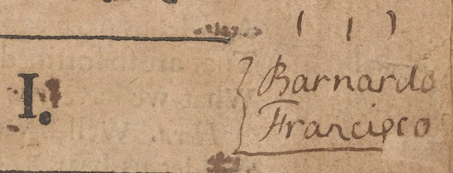
<marginalia>
<language ident="EN">
<position place="right_margin" book_orientation="0">
<marginalia_text>
(1)
Barnardo
Francisco
</marginalia_text>
<person name="Barnardo"/>
<person name="Francisco"/>
</position>
</language>
</marginalia>
Example 3 – anchored text:
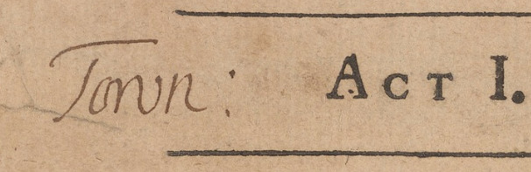

<marginalia anchor_text="Act I.">
<language ident="EN">
<position place="left_margin" book_orientation="0">
<marginalia_text>
Town:
</marginalia_text>
</position>
</language>
</marginalia>

Example 4 – anchored text & supplied letters:
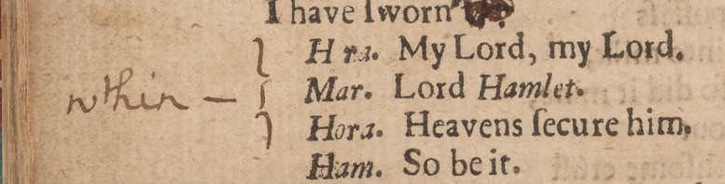
<marginalia anchor_text="Hora. My Lord, my lord.">
<language ident="EN">
<position place="left_margin" book_orientation="0">
<marginalia_text>
w[i]thin
</marginalia_text>
</position>
</language>
</marginalia>

Example 4 – Ambiguous case: anchored or not anchored? If in doubt, don't anchor.
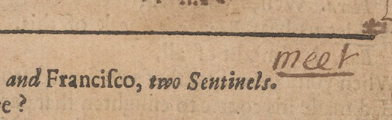
Example 5 – Uncertainty about text – Added “Unsure” as comment

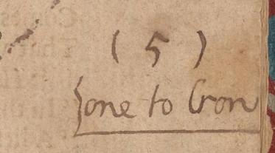
<marginalia>
<language ident="EN">
<position place="right_margin" book_orientation="0">
<marginalia_text>
(5)
one to Cron <!-- Unsure -->
</marginalia_text>
</position>
</language>
</marginalia>

Substitution – Replacement:

Example 1:


<substitution method="pen" type="replacement" copyText="I could not believe this," amendedText="I could not this believe,"/>

Example 2

<substitution method="pen" type="replacement" copyText="Makes the night joynt labour with the day?" amendedText="Making the night joynt labourer with the day?"/>

Substitution – Insertion:

Example 1 – Marginalia or insertion?
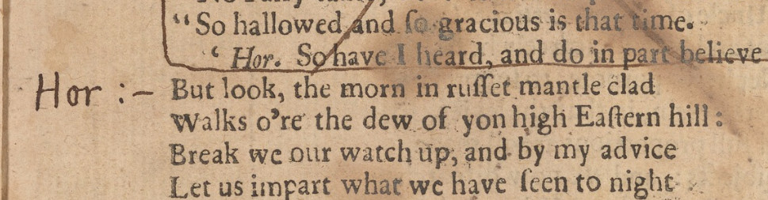
Example 2 – Punctuation:
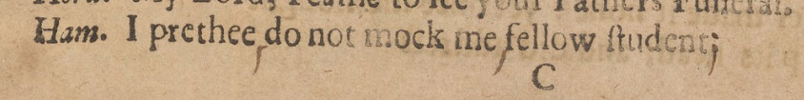
<substitution method="pen" type="insertion" copyText="I prethee do not mock me fellow student" amendedText="I prethee, do not mock me, fellow student;"/>

Example 3 – Words:
<substitution method="pen" type="insertion" copyText="I'll make a Ghost of him that letts me:" amendedText="By heav'n, I'll make a Ghost of him that letts me: --"/>

Substitution – Deletion:

Example 1 –
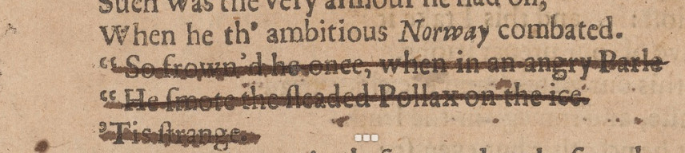
<substitution method="pen" type="deletion" copyText="'' So frown'd he once, when in angry Parle | '' He smote the sleaded Pollax on the ice | 'Tis strange." amendedText=""/>

Two things to remember:
Use the vertical bar (|) after every line
Use two single quotation marks (') and space before lines that are preceded by quotes

Example 2:
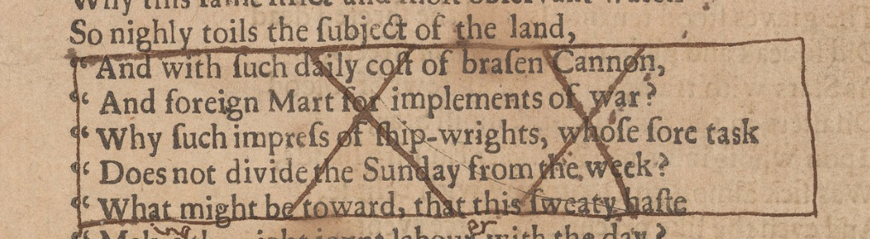
<substitution method="pen" type="deletion" copyText="
'' And with such daily cost of brasen Cannon, |
'' And foreign Mart for implements of war? |
'' Why such impress of ship-wrights, whose sore task |
'' Does not divide the Sunday from the week?
'' What might be toward, that this sweaty haste" amendedText=""/>

Symbols:
Hatching – Example 1 :
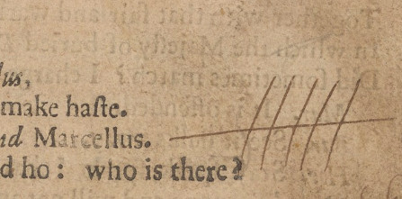

<symbol name="Hatching" place="right_margin"/>

Marks:
X_sign – Example 1

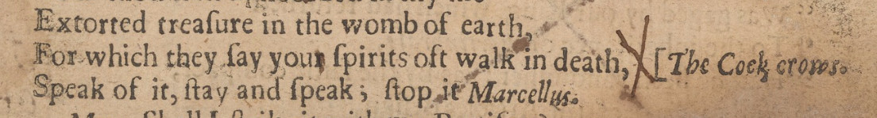
<mark name="X_sign" method="pen" place="right_margin" text="For which they say you spirits oft walk in death,"/>

